Task 1

Html

<!DOCTYPE html>

<html lang="en">

  <head>

    <meta charset="UTF-8" />

    <meta name="viewport" content="width=device-width, initial-scale=1.0" />

    <title>Document</title>

    <link rel="stylesheet" href="index.css" />

  </head>

  <body>

    <div>

      <h1>Start CSS Excercise</h1>

      <p>Good luck!</p>

      <button>Start CSS Excercise</button>

    </div>

  </body>

</html>

CSS

div {

  background-color: rgba(0, 0, 0, 0.772);

  padding: 0.5rem;

}

h1,

p {

  color: white;

  font-family: sans-serif;

  font-weight: 200;

}

button {

  background-color: rgb(8, 161, 54);

  color: white;

  padding: 1rem;

  font-weight: 600;

}

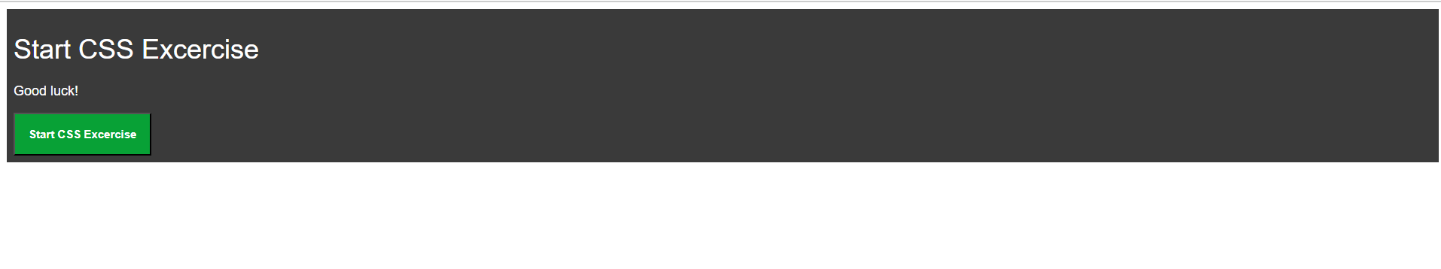

Task 2

html

<!DOCTYPE html>

<html lang="en">

  <head>

    <meta charset="UTF-8" />

    <meta name="viewport" content="width=device-width, initial-scale=1.0" />

    <title>Document</title>

    <link rel="stylesheet" href="index.css" />

  </head>

  <body>

    <div>

      <form>

        <input type="text" placeholder="Name*" id="name" />

        <br />

        <input type="text" placeholder="Username*" id="username" />

        <br />

        <input type="password" placeholder="Password*" id="password" />

        <br />

        <input type="number" placeholder="Number*" id="number" /> <br /><input

          type="email"

          placeholder="Email Id*"

          id="email"

        />

        <br />

        <input type="button" value="Register" class="btn" />

      </form>

    </div>

  </body>

</html>

Css

div {

  background-color: rgba(0, 0, 0, 0.772);

  margin: 0 auto;

  width: 600px;

  background-color: rgb(31, 109, 255);

}

form {

  padding: 3rem;

}

input {

  padding: 0.75rem;

  padding-right: 18.3rem;

  margin: 0.5rem;

}

.btn {

  width: 95%;

  text-align: center;

  padding: 0.75rem; /* Adjust padding as needed */

  background-color: brown;

  color: white;

}

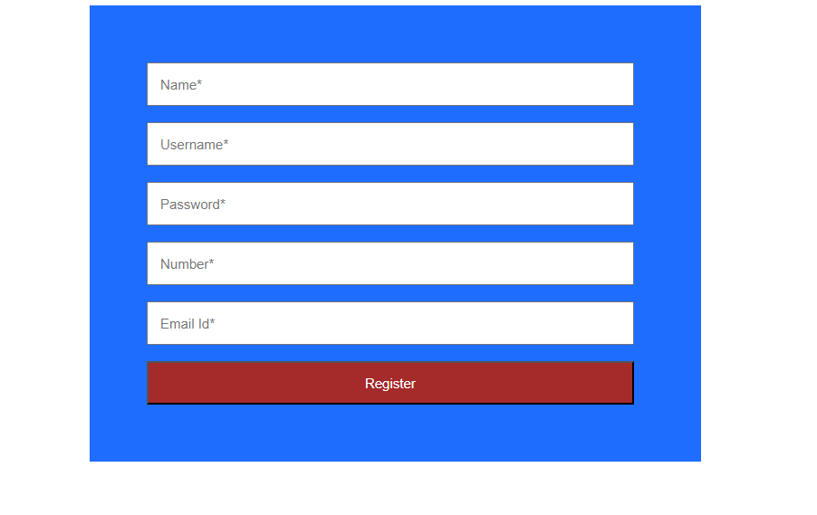

Task 3

Html

<!DOCTYPE html>

<html lang="en">

  <head>

    <meta charset="UTF-8" />

    <meta name="viewport" content="width=device-width, initial-scale=1.0" />

    <title>Document</title>

    <link rel="stylesheet" href="index.css" />

  </head>

  <body>

    <div class="card">

      <img src="forest-landscape_71767-127.avif" alt="card" />

      <div class="card-content">

        <h2>Cinque Terre</h2>

      </div>

    </div>

  </body>

</html>

Css

.card {

  margin: 0 auto;

  width: 500px;

  border: 1px solid #ccc;

  border-radius: 12px;

  overflow: hidden;

  box-shadow: 8px 8px 8px 8px rgba(0, 0, 0, 0.5);

}

.card-content {

  text-align: center;

  color: black;

  font-family: sans-serif;

  font-weight: 0;

}

Task 4

Html

<!DOCTYPE html>

<html lang="en">

  <head>

    <meta charset="UTF-8" />

    <meta name="viewport" content="width=device-width, initial-scale=1.0" />

    <title>Document</title>

    <link rel="stylesheet" href="index.css" />

  </head>

  <body>

    <div class="div">

      <div class="card">

        <img src="forest-landscape_71767-127.avif" alt="card" />

        <div class="card-content">

          <h2>Cinque Terre</h2>

        </div>

      </div>

    </div>

  </body>

</html>

Css

.div {

  width: 70%;

  animation: moveRight 2s ease-in-out forwards;

}

.card {

  width: 500px;

  border: 1px solid #ccc;

  border-radius: 12px;

  overflow: hidden;

  box-shadow: 8px 8px 8px 8px rgba(0, 0, 0, 0.5);

}

.card-content {

  text-align: center;

  color: black;

  font-family: sans-serif;

}

@keyframes *moveRight* {

  from {

    transform: translateX(0);

  }

  to {

    transform: translateX(100%);

  }

}

